<INSERT DATE OF VOLUNTEERING>

To Whom It May Concern

This letter serves to confirm that <INSERT NAME HERE> is a volunteer of PlateitForward Limited and is travelling for essential business purposes.

PlateitForward is a not-for-profit organisation and is registered as a charity with the Australian Charities and Not-for-Profits Commission (ACNC). PlateitForward was established in June 2020 and provides essential food relief and employment pathways to vulnerable communities across Sydney.

PlateitForward prepares and delivers meals to thousands of vulnerable people and families in Sydney each week. An essential part of the Volunteer's role includes the need to travel to facilitate the provision of support and food to those we serve. This will include, amongst others, assisting with distribution and transport of food.

As such this is unable to be done from the employee's home.

Should you require any further or additional information, please do not hesitate to contact me at pedro@plateitforward.org.au or on +61 481 722 667.

Yours sincerely
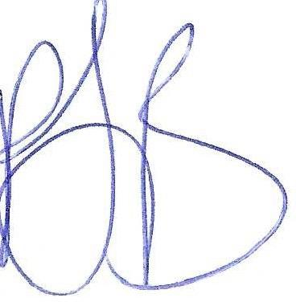

Peter Jones-Best Managing Director

PlateitForward Limited 159 Enmore Road, Enmore, NSW, 2042 ABN: 35 641805 432 Email: help@plateitforward.org.au Website: www.plateitforward.org.au

